**EXPERIMENT 10**

**Create a simple cloud software application to run a c program to display the student information using any Cloud Service Provider to demonstrate SaaS with the template of student name, Reg no, address, phone, age, courses, grades and attendance report, progress report, Semester mark sheet forms**

Step1: Create an application called ‘STUDENT INFORMATION’

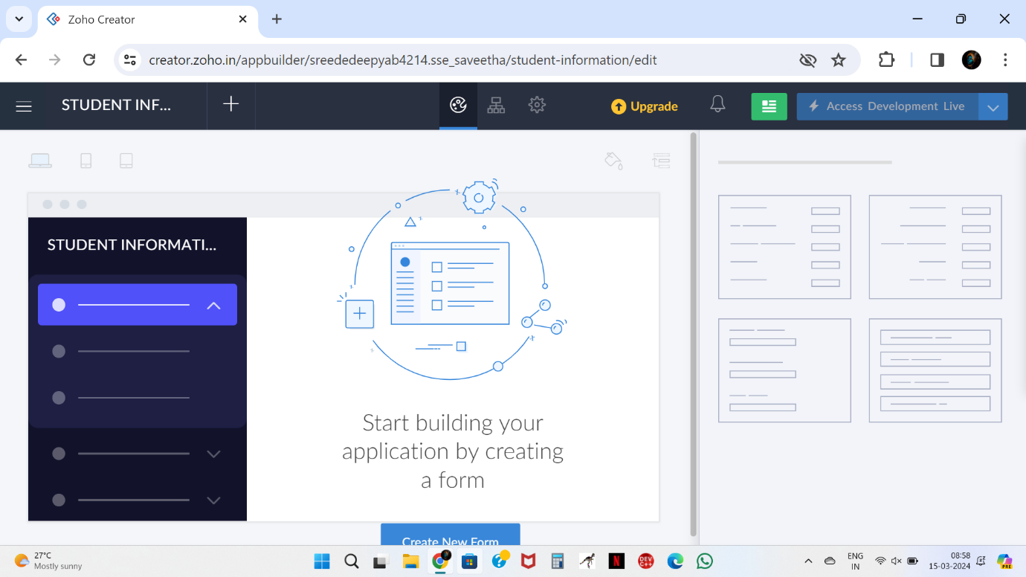

Step2: Create a form called ‘ Student details ‘

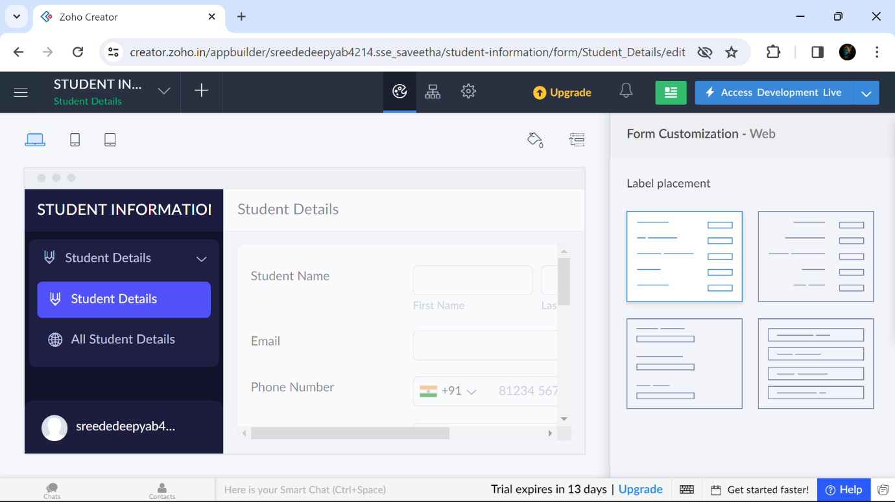

Step3: Create a form called as ‘ Course‘

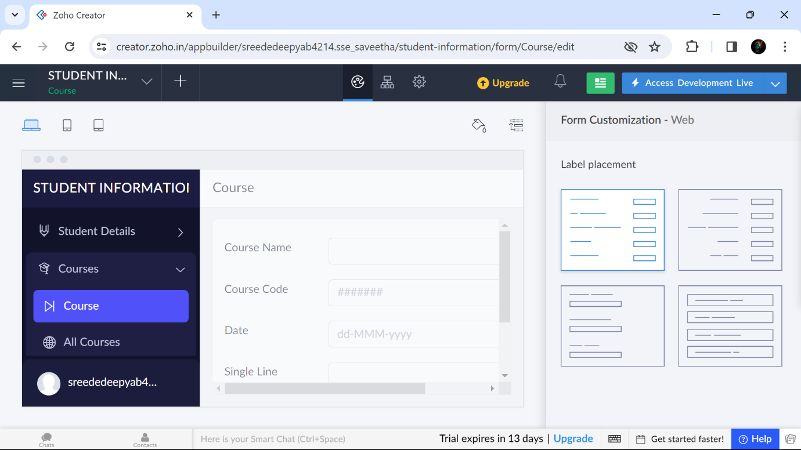

Step4: Create a form called ‘Attendance’

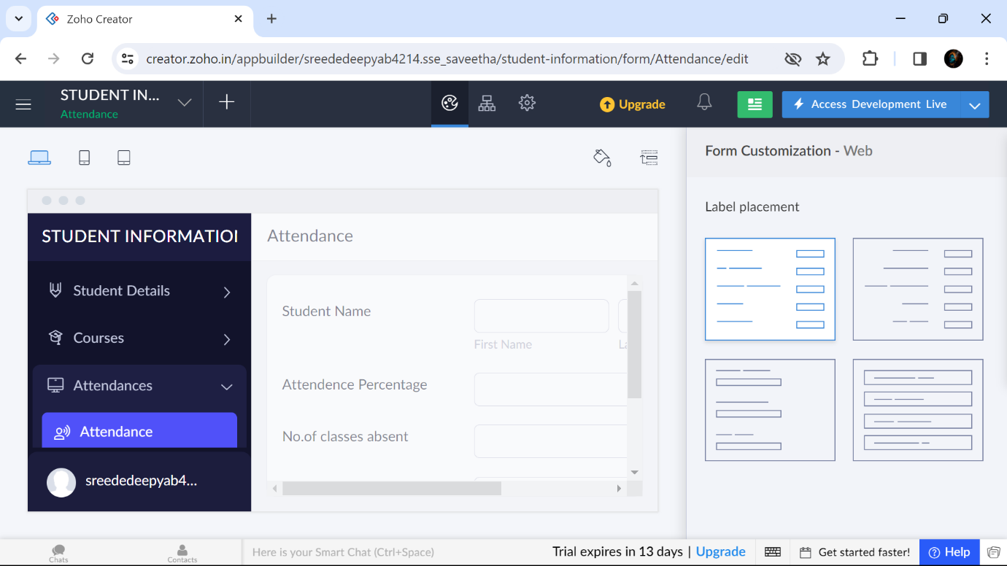

Step 5: Displaying the details entered in ‘Student details’

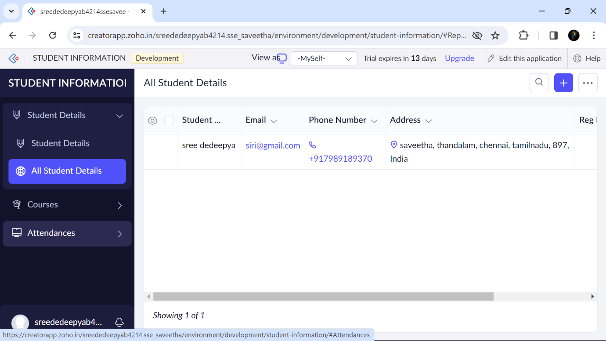

Step 6: Displaying the details entered in ‘Course’

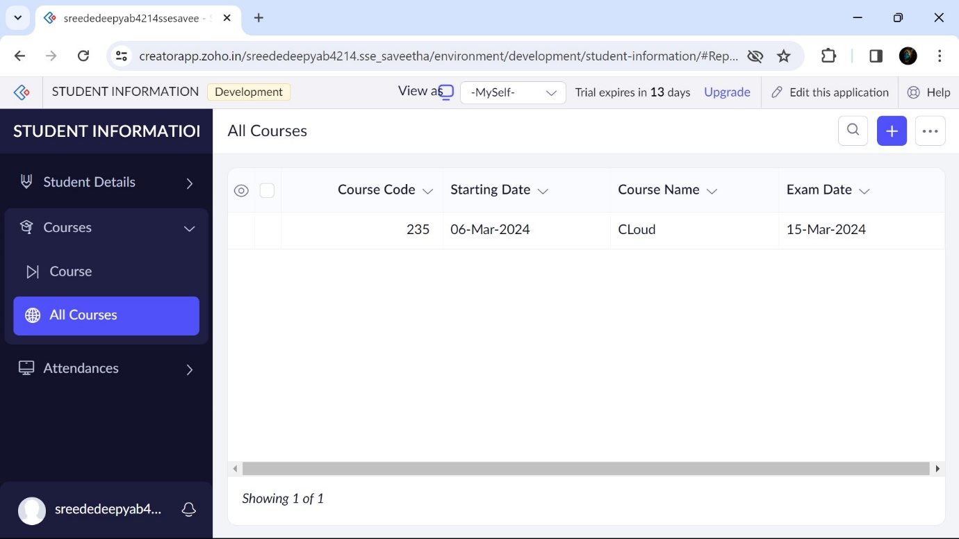

Step 7: Displaying the details entered in ‘Attendance’

